要求：钢棍冷折成型，不允许加热

Y型双杈钯钉（锚固钉^φ16×221^Y型^0Cr25Ni20）

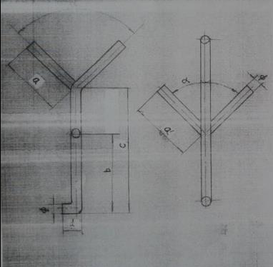

|  |  |  |  |  |  |  |  |  |  |  |  |
| --- | --- | --- | --- | --- | --- | --- | --- | --- | --- | --- | --- |
| 型号 | 尺寸（mm) | | | | | | | 总高（mm) | 总长（mm) | 单重 | 材质 |
| φ | a | a＇ | b | c | d | ∂ |
| Yφ16*221/90-2 | 16 | 115 | 80 | 60 | 140 | 40 | 90 | 221 | 554 | 0.87 | 0Cr25Ni20 |

Y型钯钉（锚固钉^φ16×147^Y型^0Cr25Ni20）

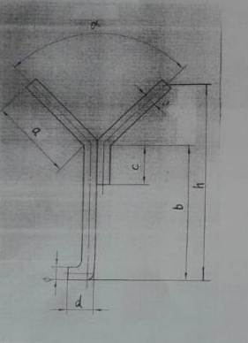

|  |  |  |  |  |  |  |  |  |  |  |
| --- | --- | --- | --- | --- | --- | --- | --- | --- | --- | --- |
| 型号 | 尺寸（mm) | | | | | | | 总长（mm) | 单重（kg) | 材质 |
| φ | a | b | c | d | h | ∂ |
| Yφ16*147/90 | 16 | 80 | 90 | 40 | 50 | 147 | 90 | 324 | 0.51 | 0Cr25Ni20 |

V型钯钉（锚固钉^φ14×120^V型^0Cr25Ni20）

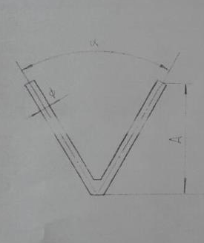

|  |  |  |  |  |  |  |  |
| --- | --- | --- | --- | --- | --- | --- | --- |
| 型号 | 尺寸（mm) | | | | 总长（mm) | 单重（kg) | 材质 |
| φ | A | ∂ | 边长 |
| Vφ14*120/60 | 14 | 120 | 60 |  |  |  | 0Cr25Ni20 |