Y型钯钉

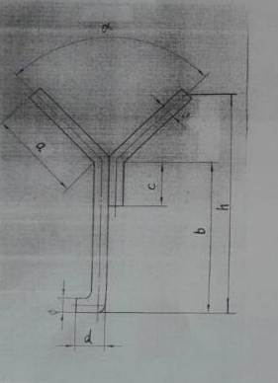

|  |  |  |  |  |  |  |  |  |  |  |
| --- | --- | --- | --- | --- | --- | --- | --- | --- | --- | --- |
| 型号 | 尺寸（mm) | | | | | | | 总长（mm) | 单重（kg) | 材质 |
| φ | a | b | c | d | h | ∂ |
| Yφ16×250/90 | 16 | 150 | 145 | 40 | 50 | 250 | 90 |  |  | 0Cr25Ni20 |
| YΦ16×325/90 | 16 | 150 | 224 | 40 | 50 | 325 | 90 |  |  | 0Cr25Ni20 |